Public transportation optimization

**Introduction:**

Public transportation is a crucial aspect of urban infrastructure, contributing significantly to the efficiency and sustainability of modern cities. However, the lack of real-time data and efficient scheduling often leads to inconvenience and delays for commuters. The Public Transportation Optimization project aims to revolutionize the transit experience by integrating IoT sensors into public transportation vehicles, enabling the monitoring of ridership, real-time tracking of locations, and accurate prediction of bus or train arrival times. By utilizing a comprehensive system of sensors, microcontrollers, and cloud-based platforms, this project seeks to streamline public transit operations and enhance the overall commuter experience.

**Project Description:**

The implementation of the Public Transportation Optimization project involves the integration of various IoT technologies, including GPS sensors, Arduino microcontrollers, and the esp8266 module, to facilitate seamless data collection, analysis, and dissemination. The primary components and functionalities of this system include:

**IoT Sensors Integration:**

Incorporating advanced GPS sensors within public transportation vehicles to accurately track their locations and gather real-time data on ridership and travel patterns.

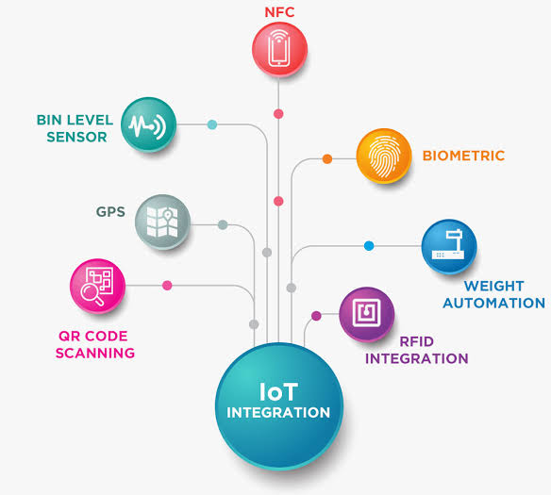

**Data Processing and Analysis:**

Utilizing Arduino microcontrollers to process the data collected from the IoT sensors and perform complex analytical tasks, such as predictive modeling for arrival times and scheduling optimizations.

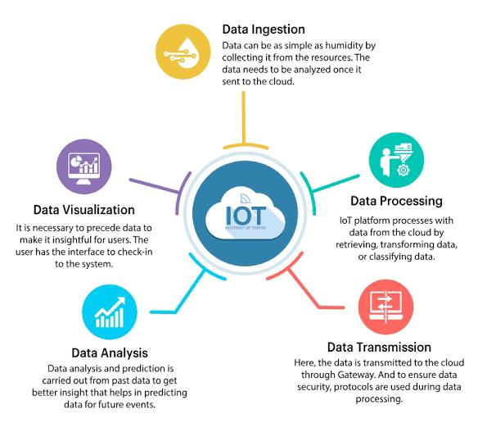

**Cloud-Based Data Management:**

Leveraging the capabilities of the esp8266 module to securely transmit the processed data to a cloud-based platform for storage, analysis, and accessibility.

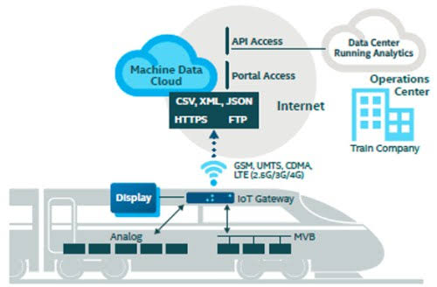

**User-Friendly Interface:**

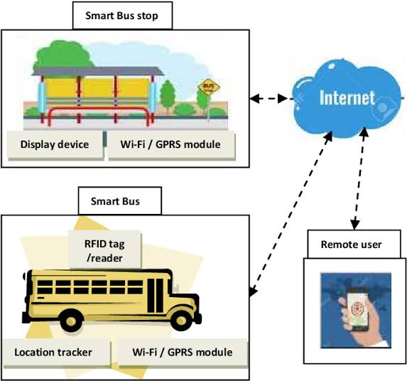Developing an intuitive and user-friendly public platform that enables commuters to access real-time information regarding the location of public transportation vehicles, anticipated arrival times, and any potential service disruptions.

**Predictive Maintenance:**

Implementing proactive maintenance strategies based on the collected data to ensure the efficient operation and longevity of the public transportation fleet.

**Project Objectives:**

**Enhance Commuter Convenience:**

By providing accurate real-time information on the locations and arrival times of public transportation vehicles, the project aims to minimize wait times and improve the overall transit experience for commuters.

**Optimize Transit Scheduling:**

Utilizing predictive modeling and data analysis, the project seeks to optimize transit scheduling, thereby reducing congestion, minimizing delays, and improving the overall efficiency of the public transportation network.

**Foster Data-Driven Decision Making:**

By leveraging the insights derived from the collected data, the project aims to empower transportation authorities to make informed decisions that enhance the quality and reliability of public transit services.

**Conclusion:**

The Public Transportation Optimization project represents a significant step towards transforming the way commuters interact with public transit systems. By harnessing the power of IoT sensors, data analytics, and cloud computing, this initiative aims to create a seamless and efficient public transportation network that prioritizes commuter convenience, operational efficiency, and sustainability. Through the integration of cutting-edge technologies and data-driven strategies, the project aspires to set new benchmarks in the realm of urban transportation, fostering smarter and more responsive public transit services for communities worldwide.